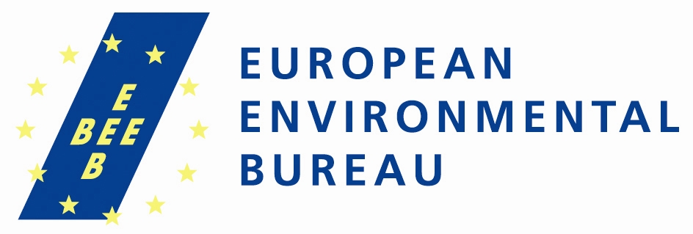
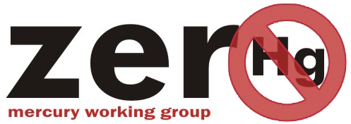
PRESS RELEASE

Mercury treaty negotiation moves forward in ‘fits and starts’

[4TH November 2011, Nairobi, Kenya] - Over 500 delegates from 125 countries met this week to continue constructing a legally-binding global mercury treaty. While the content of the draft treaty text was discussed, public interest NGOs tried to ensure that important control measures are in the streamlined new treaty text.

“Although some progress was made in terms of narrowing down the options important issues such as air emissions remain deadlocked,” said Elena Lymberidi-Settimo, Co-coordinator of the Zero Mercury Working Group. Due to its capacity for long-range transport, atmospheric emissions of mercury contribute the most to contaminating the global fish supply, threatening human health and the environment.

The delegates discussed various sources of mercury pollution to the global pool. These ranged from polluting practices in artisanal and small scale gold mining (ASGM); emissions to air and releases to water and land; products and processes; waste, storage, and contaminated sites.

Relative progress was made on mercury storage and waste sections, where new draft treaty text was agreed as a basis for discussions for the next meeting of the intergovernmental negotiating committee (INC).

“The new treaty text provides a starting framework for the storage of mercury and safe management of waste,” said Michael Bender, ZMWG co-coordinator. “We are still concerned over what seems to be the blocking of progressive moves to prohibit mercury waste dumping in developing countries.”

The new text now reflects significant agreement to address mercury use in ASGM, a large and growing source of mercury pollution. Among the remaining issues still to be resolved, is which countries will be covered by the relevant provisions and whether mercury can be imported for this use.

On products and processes, NGOs welcomed the fact that the option on voluntary approaches was removed. “It is important that such areas are regulated”, said Dr. Mahmood Khwaja, Senior Advisor, Sustainable Development Policy Institute, Pakistan. “Removing mercury from products will be one step forward towards controlling the spread of mercury contamination and is huge step towards prevention and minimisation of mercury waste”.

An expert meeting was agreed to take place before the next INC meeting (number four) to advance discussions on finances since relevant discussions stalled at this session. UNEP has been asked to prepare a revised draft treaty text as a basis for discussions at the next meeting.

“Multilateralism has to work, for our world’s sake,” stated Richard Gutierrez of Ban Toxics!, Philippines. “We can achieve this only if countries get out of their positions and begin engaging in meaningful compromises for our world and for future generations.

Notes for the editor
Mercury, a potent neurotoxin, contaminates fish supplies around the world, and poses particular risks to women and young children. The anticipated mercury treaty will address mercury pollution globally.

ZMWG Preliminary Views on the INC 3 Draft Treaty text - English version
ZMWG Position for INC 3 - Abridged version EN
Other language versions available at www.zeromercury.org

CONTACTS:
Elena Lymberidi-Settimo, Project Coordinator 'Zero Mercury Campaign' , European Environmental Bureau/ZMWG, elena.lymberidi@eeb.org, Mobile: +32 496 532818 , in Kenya +254 706 045 272.

Michael Bender, Director, Mercury Policy Project/ZMWG, mercurypolicy@aol.com, T: +1 802 223 9000

The Zero Mercury Working Group (ZMWG) is an international coalition of more than 94 public interest environmental and health non-governmental organizations from 52 countries from around the world formed in 2005 by the European Environmental Bureau and the Mercury Policy Project. ZMWG strives for zero supply, demand, and emissions of mercury from all anthropogenic sources, with the goal of reducing mercury in the global environment to a minimum. Our mission is to advocate and support the adoption and implementation of a legally binding instrument which contains mandatory obligations to eliminate where feasible, and otherwise minimize, the global supply and trade of mercury, the global demand for mercury, anthropogenic releases of mercury to the environment, and human and wildlife exposure to
mercury. (www.zeromercury.org)

The European Environmental Bureau (EEB), www.eeb.org , is a federation of over 150 environmental citizens’ organisations based in most EU Member States, most candidate and potential candidate countries as well as in a few neighbouring countries. EEB is the environmental voice of European citizens, standing for environmental justice, sustainable development and participatory democracy. We want the EU to ensure all people a healthy environment and rich biodiversity.

